Objective:

* Config NGINX L7 Load Balancer using single VM and deploy 2 services names with api.poridhi.io and fr.poridhi.io

Steps:

1. Create VPC

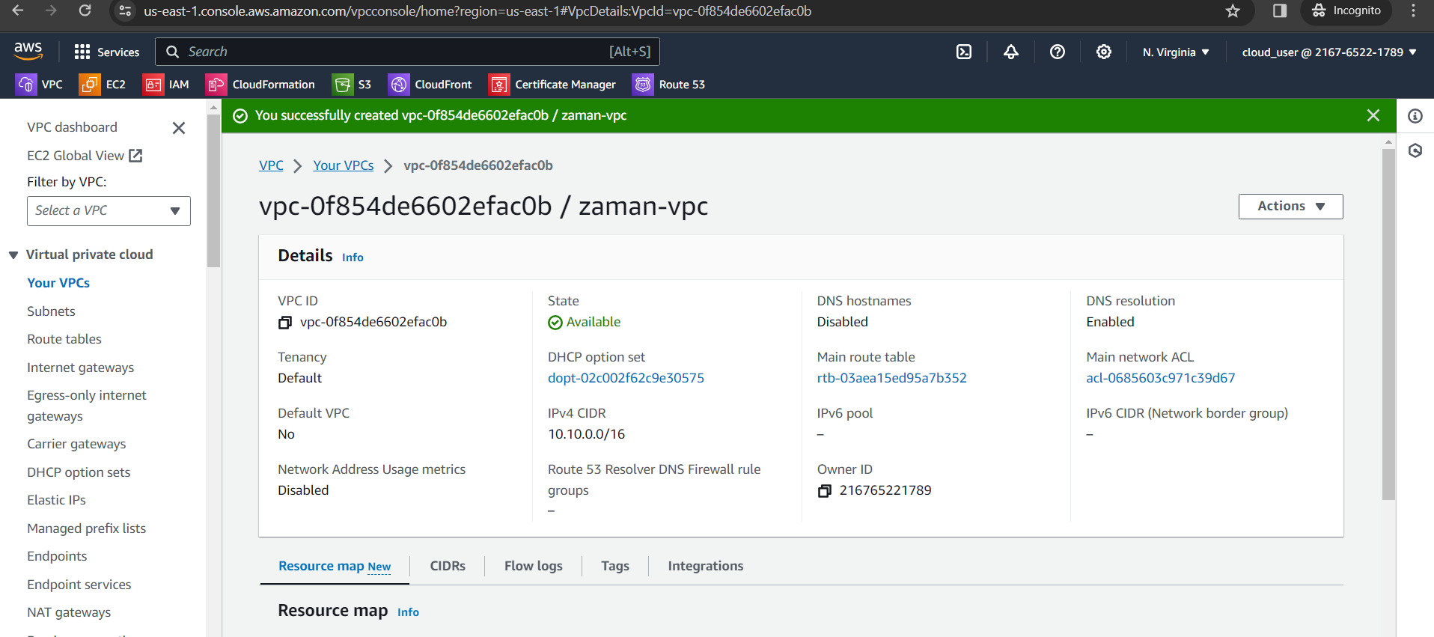

1. Create Subnet

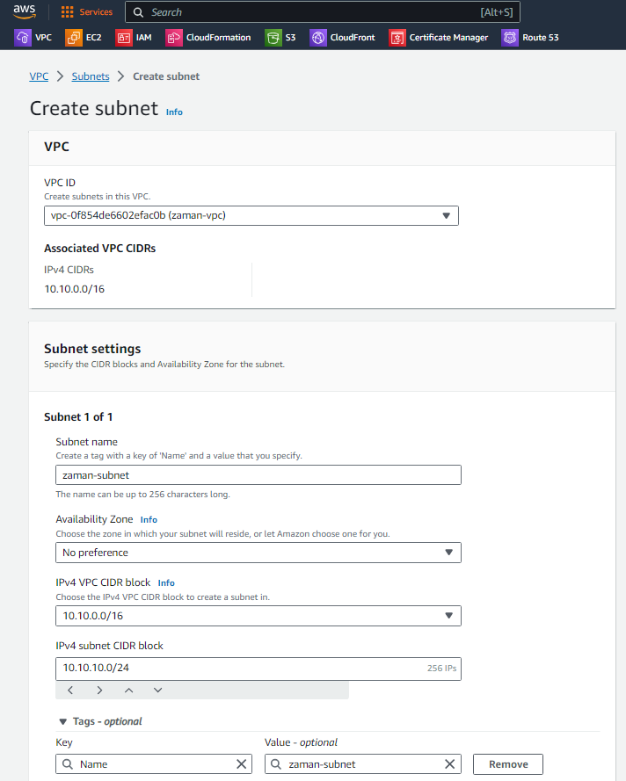

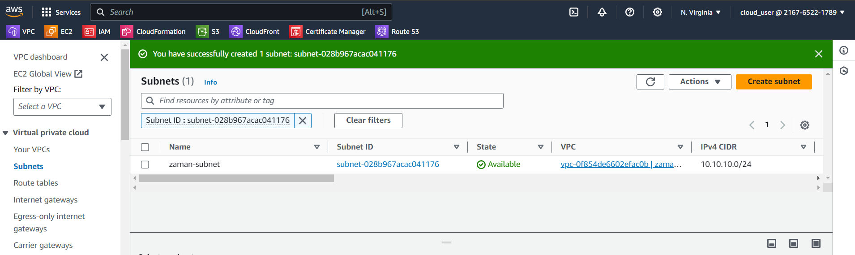

1. Create Internet Gateway and attach to the VPC

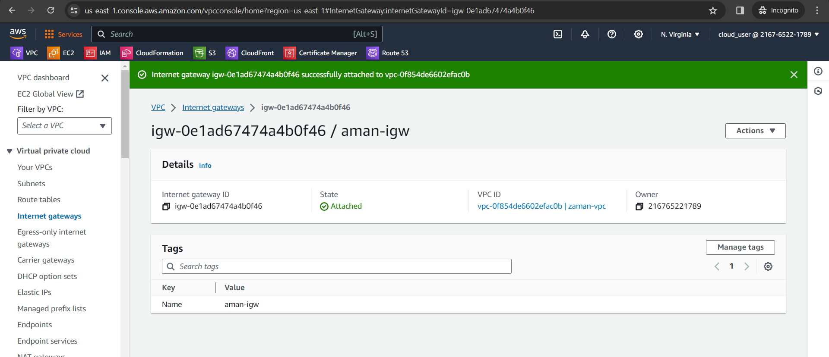

1. Add route 0.0.0.0

